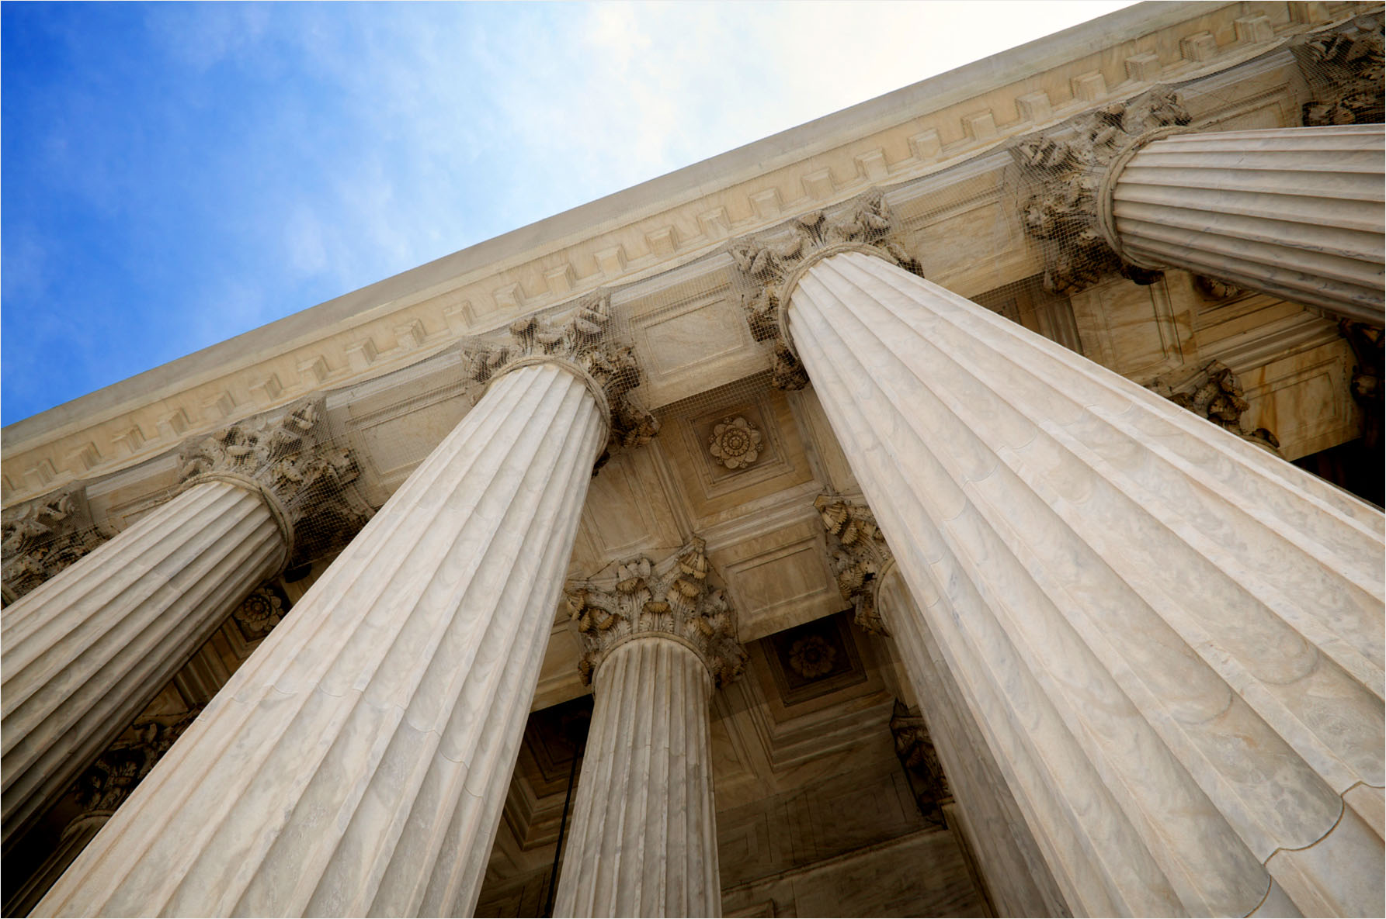

Northside Art Gallery Website

REPORT SUBTITLE

Jordan Rogers | 12/03/2021

1. Brief overview of the gallery and website requirements (including pages, images, logo requirements and target audience). Include a**checklist** which will be used later (in Assessment Task 4 – AT4) to check against the client requirements.

Northside Art Gallery is a large gallery that is located within Chermside, Queensland. Northside Art Gallery is consistently have at least one exhibition running along with several other exhibitions in different stages of completion. Northside Art Gallery wants to include a contact page so that people can enquire about the exhibitions and any other possible enquiries. The company has been commissioned to build a platform independent website to further help promote their current and future planned exhibitions. Overall the list of all the pages are the homepage that’ll first be presented, followed by the current and future exhibition pages, the next page is the about us page, contact page and lastly the copyright page, however the copyright page will not be visible from the navigation, it’ll only be accessible from clicking on the link at the bottom of each page.The director has asked that when creating the website that we keep the budget to a minimum.

**Pages**

Homepage: Organisation profile page

Current Exhibition: Current exhibition information page with minimum of 3 images along 1 row

Future Exhibition: Future exhibition information page with minimum of 6 images along 2 row

Contact Us: Contact information, address/location, phone, email, and a feedback comment/feedback section

Copyright: Information of the “Copyright Act 1968” and “Privacy Act 1998”. Copyright is the use of someone else’s original work, such as a photo taken by someone or an article written by someone else on the web.

About Us: Contains information of the organisation themselves

**Images (and logo)**

We are gathering our placeholder images from Pexels, a place that gives free photo images for free use, so long as it is not used for the use of earning money.

Target Audience

Target audience will be any and everyone who is interested in looking for amazing websites that help people find art galleries.

Requirements Checklist (at least 15)

|  |  |
| --- | --- |
| Item | Status |
| Logo |  |
| Banner |  |
| Images |  |
| Nav bar |  |
| Footer |  |
| Social icons |  |
| Home page |  |
| Homepage image |  |
| Current exhibition page |  |
| Current exhibition images |  |
| Future exhibitions page |  |
| Future exhibition images |  |
| Contact us page |  |
| Location of gallery image |  |
| Comment box |  |
| Submit button |  |
| Headings |  |
| Descriptions of the images |  |
| Copyright information |  |
| Link pages |  |
| Link Copyright page |  |

1. Brief explanation of privacy issues to consider for the website (covering 2 points)
   * “The Privacy Act”: The Privacy Act was set in stone to protect any and everyone from just any individual from accessing any information of yours that you give out to someone, such as a doctor, website, and many other places you may give out your personal information out to.
   * “Privacy by Design”: Privacy by design is approaching systems engineering that looks to help people feel safe when it comes to their protection for privacy of their data, this is something we associate companies using, such as social platforms that promise to protect your data from damage.
2. Brief explanation of accessibility issues to consider for the website (covering 2 points)
   * Keyboard friendly: Anything that the mouse can do, a keyboard should be able to also accomplish. So, someone with a keyboard should have a very similar experience navigating and interacting on the Web as a user with just a mouse.
   * Sequential Heading Structure: Headings are critical for navigation and content organisation. The headings need to be coded as headings in the proper sequence. If not coded properly then not everyone will be able to navigate and fully understand the content equally.
3. A preliminary site map to guide the site navigation design
4. Review the client image requirements and make a list of the required images for your website. Discuss:

* Expected image quality

Image quality is expected to be high quality images that remain that quality for viewing purposes, there shouldn’t be any issues seeing pixels within the images.

* Copyright requirements

Must follow the “Copyright Act 1968” and the “Privacy Act 1998”. Copyright is the use of someone else’s original work, such as a photo taken by someone or an article written by someone else on the web. The copyright requirements from Northside Gallery ask that images are royalty free, so that we are using images without trying to earn a profit from them.

* Images size/resolution

|  |  |
| --- | --- |
| Image | Pixels |
| Logo | 300px x 282px |
| Banner | 1156px x 200px |
| Homepage image | 300px x 300px |
| Facebook icon | 50px x 50px |
| Instagram Icon | 50px x 50px |
| Twitter icon | 50px x 50px |
| Contemporary image 1 | 900px x 600px |
| Contemporary image 2 | 1200px x 1186px |
| Contemporary image 3 | 524px x 524px |
| Future exhibition image 1 | 2456px x 1608px |
| Future exhibition image 2 | 2244px x 1440px |
| Future exhibition image 3 | 1830px x 1475px |
| Future exhibition image 4 | 524px x 524px |
| Future exhibition image 5 | 347px x 268px |
| Future exhibition image 6 | 400px x 409px |
| Google maps image | 512px x 535px |

* Images file format

Image file format will either be a JPG or PNG.

1. Compare three (3) industry recognised image editing tools (e.g. Photoshop, Gimp) against at least four (4) different criteria – you can present this information in a table. Select one of these to complete your website.

|  |  |  |  |  |
| --- | --- | --- | --- | --- |
| Name | Cost | Platform Support | Features/advantage | Features/disadvantage |
| Photoshop | $29.99 monthly | Microsoft, Apple, Microsoft surface, iPad, Wacom 1 | Industry standard  Extensive plugin library that extends functionality  Integrates with Adobe Creative Cloud  Mobile companion apps | Cost (relative)  Requires higher end hardware to run effectively  Learning Curve |
| Photopea | Free | Compatible with multiple web browsers, including Opera, Edge, Chrome, and Firefox. | Advanced Web Based Image Editor / Photoshop Alternative.  Requires no special hardware or browser plugins  Available to anyone with a browser and an internet connection  Can work with PSD and Sketch files | Does not provide the level of functionality for advanced users  Lacks decent RAW support  Some performance issues working with large files |
| Affinity Designer | $79.99 | Mac, Windows and iPad | Split Screen and Outline Views  UI, Web, and App Design Optimisation  Dynamic Precision Guides  Advanced Grids  Create Accurate Designs  Dynamic Symbols  Advanced File Support | Importing photoshop brushes doesn't import dynamic brush qualities  No plugin support for Designer  Difficult to sync changes made to one document across a range of other documents |
| Tool selected for the project: Photopea | | | | |